**Menu Utama**

1. Buat menu pada project melalu tab other, klik tab **Other** 🡪 klik **Menu** 🡪 klik **New**

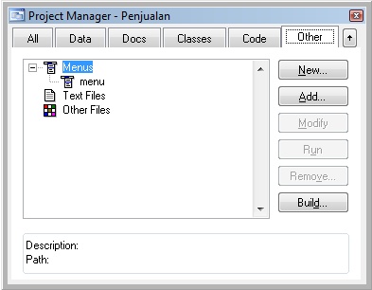

1. Pilih Menu

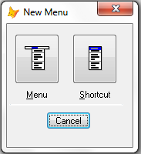

1. Isikan struktur menu sbb:

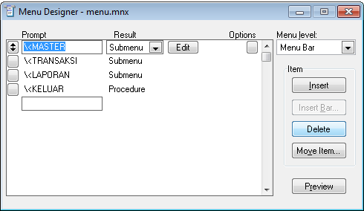

|  |  |  |  |
| --- | --- | --- | --- |
| Menu Bar | |  |  |
| \<MASTER | | Submenu |  |
|  | Data Barang | Command | do form frm_barang.scx |
|  | Data Konsumen | Command | do form frm_konsumen.scx |
|  | Data Sales | Command | do form frm_sales.scx |
|  | Data Kolektor | Command | do form frm_kolektor.scx |
| \<TRANSAKSI | | Submenu |  |
|  | Penjualan | Command | do form frm_jual.scx |
| \<LAPORAN | | Submenu |  |
|  | Laporan Barang | Command | repo form rpt_barang.frx prev |
|  | Laporan Konsumen | Command | repo form rpt_konsumen.frx prev |
|  | Laporan Sales | Command | repo form rpt_sales.frx prev |
|  | Laporan Kolektor | Command | repo form rpt_kolektor.frx prev |
| \<KELUAR | | Procedure | APPLICATION.ACTIVEFORM.RELEASE() |
|  |  |  |  |

1. Atur menu dengan klik menu **view** 🡪pilih **General Option** 🡪 beri centang pada checkbox **Top-Level Form** 🡪 klik **OK**

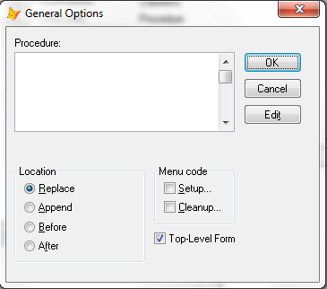

1. Simpan menu, beri nama menu.mnx
2. Genereate file MPR menu dengan cara, klik **menu** menu 🡪pilih **Generate** 🡪klik tombol Generate

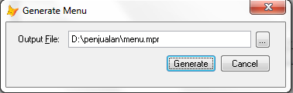

1. Tutup window menu designer

**Form Utama**

1. Buat Form baru di dalam project penjualan

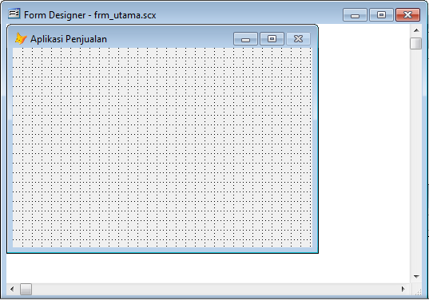

1. Atur Properties form utama sebagai berikut

|  |  |
| --- | --- |
| **Propertis** | **Nilai** |
| Caption | Aplikasi Penjualan |
| ShowWindow | 2 – As Top-level Form |
| WindowState | 2 - Maximized |

1. Atur pada masing-masing form Master (Form Barang, Form Konsumen, Form Sales, Form Kolektor), sbb:

|  |  |
| --- | --- |
| **Propertis** | **Nilai** |
| ShowWindow | 1 – In Top-level Form |
| AutoCenter | .T. - True |

1. Tulis kode program method berikut ini:

|  |  |  |  |
| --- | --- | --- | --- |
| **Object:** | frmUtama | **Procedure:** | Activate |

SET DEFA TO D:/PENJUALAN/

DO menu.mpr WITH thisform,.T.